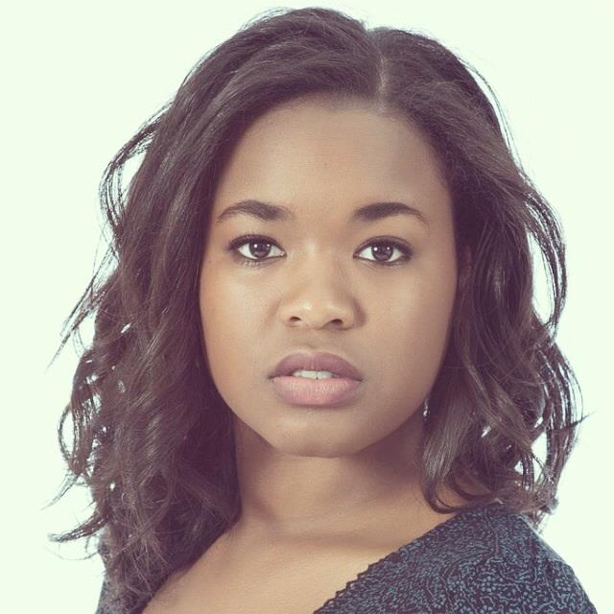
Brianna Renee Woods
Based in Overland Park and Lawrence Ks.

Birth date: 11/21/1994
Eyes: Deep Brown
Hair: Black/Brown
Height: 5” 3’
Weight: 140

______________________________________________________________________________________________________________________________
STAGE (Most Recent )
*Shrek The Musical Rupunzel/Duloc Dancer/Blind Mouse Theatre in the park-Tim Bair
Merely Players Rosalind J.I.S.T - Lynn Deboeck
Spilled Time Chinese Doctor/Martial Artist Kansas Univesity -Christoph Nevins
The Last Cyclist Lunatic 1/ Franta Kansas University - Rachel Blackburn
*Frenchy Bernadone Show El Camile/Lady Chastit Kansas Theatre Project- Peter Zazzali
Antic Disposition Ophelia/Hamlet/Gertrude Kansas University -Multiple Directors
*The Music Man Eulalie Mackechnie Shinn Blue Valley– Tim Bair/Marsha Moeller
Noises Off Mrs. Clackett (Dotty) Blue Valley - Jeff Yarnell
*Rhythm City Reyna Immeasurable Productions- Jeremy Moritz
The Foreigner Betty Blue Valley -Jeff Yarnell
Harvey Ruth Kelly Blue Valley - Jeff Yarnell
FILM
KU Diversity Training Video Supporting University of Kansas
First Last and Forever May Oldfather Studios – Michael Coy
https://www.youtube.com/watch?v=MyArDKDRaEA________________________________
OTHER EXPERIENCES AND ACHEIVEMENTS
Performer at Performer at KC Rep's annual Gala with Nathan Tysen and Joe's Pet Project 2015
Recipient of New Theatre Guild Dodie Myers Brown Scholarship
Named Performer of the Year 2013
Captain of the “Fifth Wall” Improv.Team 2013: Winning Team of The 2013 State Championship________________
EDUCATION AND TRAINING
Continuing education as a junior in the University of Kansas Theatre and Voice Programs
Acting: Peter Zazzali, John Stanuinas, Paul Meier
Speech: Paul Meier and Peter Zazzili
Movement: Leslie Bennett
Musical Theatre: Marsha Moeller, John Stanuinas, Ryan McCall
Classical Voice: Marie Learner-Sexton, Robert McNichols, Baby Lee, Isaac Cates___________________________________
SPECIAL SKILLS
Experience in Chekhov and Stanislavski, Improv, Extensive Singing Experience -both classical and current, Italian and Spanish Language, basic cheer and tumbling, Learning Piano, Accents including Southern American and Deep south, Russian, German, Standard RP, Cockney and several others, Incredibly Funny Faces. Make-Up and Costume experience. I can learn to do anything asked of me very quickly!

