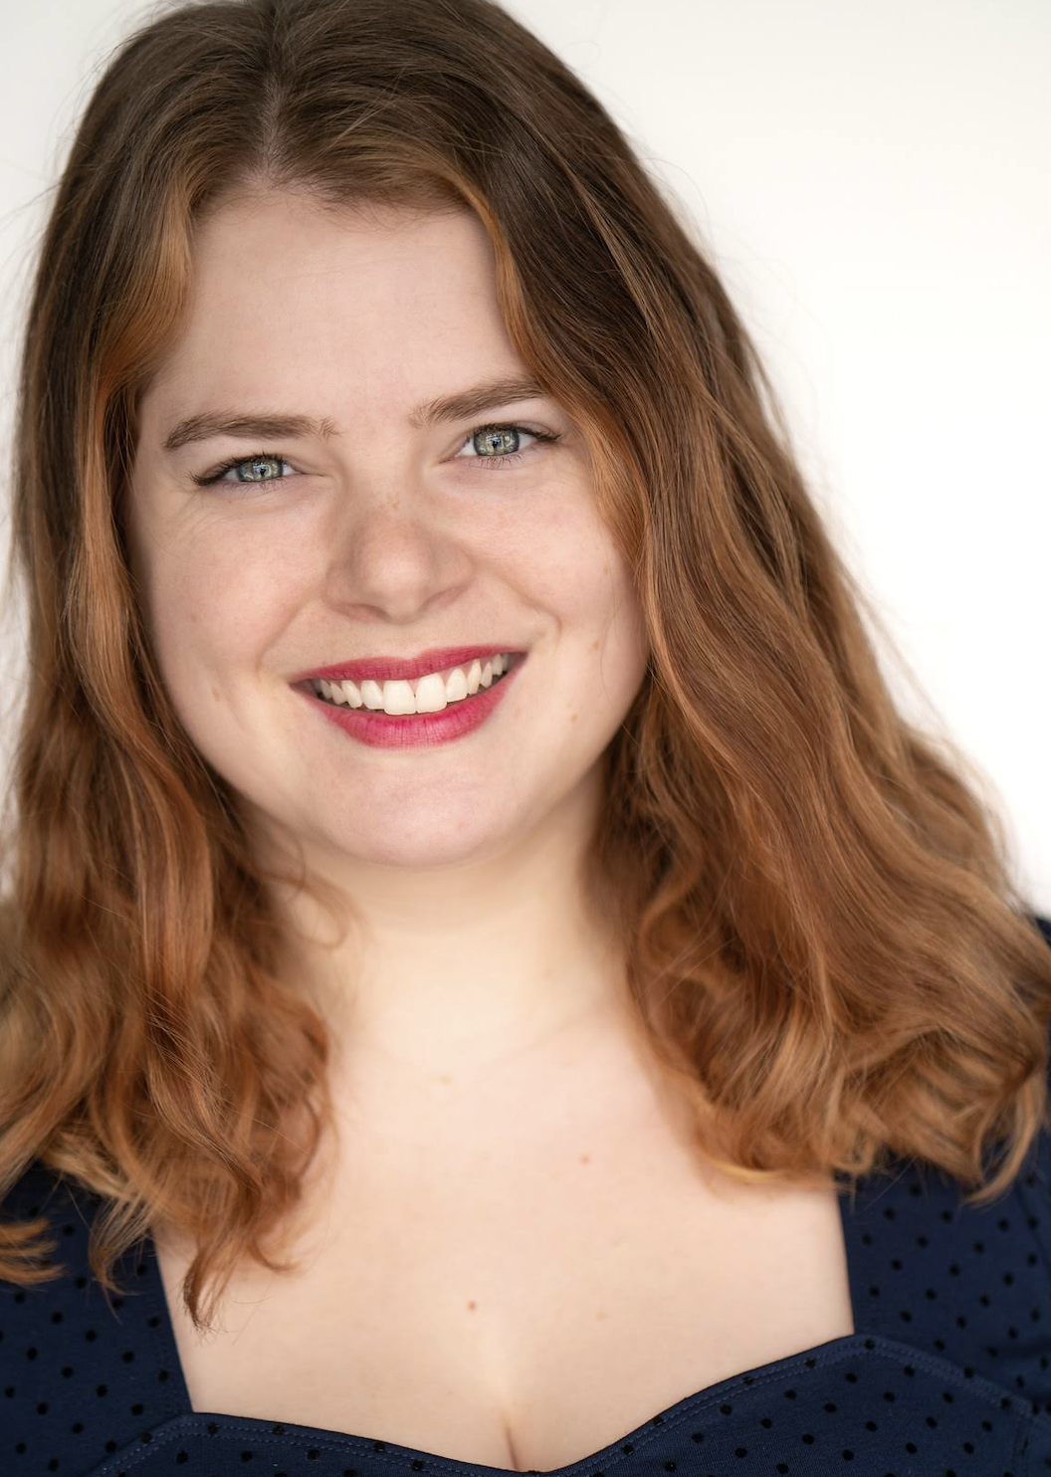
MARIANNE MCKENZIE

www.mariannemckenzie.com
EMC
Kansas City Representation: Exposure Talent
Height: 5’6”
Range: Mezzo-Soprano __________________________________________________________________________________________
FILM & VOICE OVER DIRECTOR COMPANY
Disney Vignettes (The Little Mermaid) Narrator Dir. Lars Ruch Disney
Music For All Jazz Singer Dir. Jerry Mañan Kansas City 48h Film Festival
TV/radio spots Spokesperson Dir. Isaac Moreno Quintiles/IQVIA
_____________________________________________________________________________________________ SELECTED REGIONAL THEATRE
Shakespeare in Love Ensemble/Bodhrán Sidonie Garrett Heart of America Shakespeare
A Christmas Carol Laundress/Giggly Sister Marissa Wolf Kansas City Repertory Theatre
^Dracula: A Song of Love and Death Mina Harker John Rensenhouse Kansas City Actor’s Theatre
Secret Soldiers: Heroines in Disguise Jacobs, Lois, Loreta Jeff Church/Bree Elrod The Coterie Theatre
Men on Boats Andrew Hall Missy Koonce Unicorn Theatre
Letters from Freedom Summer Joan Mulholland Ricardo Khan KC Repertory Theatre/UMKC
The Penis Monologues Ensemble Heidi Van The Fishtank
No Exit Inez Ethan Zogg The Fishtank
An Adult Evening of Shel Silverstein Ensemble Heidi Van The Fishtank
Madam Imaginaria’s Magic Lantern Madam Imaginaria Wrote/Performed National Museum of Toys/
^world premiere Miniatures

SELECTED EDUCATIONAL THEATRE
^^The Storytelling Project Kusillo Karen Lisondra UMKC Theatre
The Game of Love & Chance Lisette Theodore Swetz UMKC Theatre
Julius Caesar Calpurnia/Lucius Carla Noack UMKC Theatre
Go. Please. Go. Andrea/Emily’s Mom Joshua Brody UMKC Theatre
^^world premiere and upcoming summer 2019 international tour/remount in Bolivia
__________________________________________________________________________________________________
TRAINING
M.F.A. Acting and Directing University of Missouri-Kansas City
B.A. Theatre-Performance and French University of Missouri-Kansas City
Midsummer in Oxford Program British American Drama Academy

Acting: Theodore Swetz, Sir John Gorrie, Irena Brown, Carla Noack
Voice/Speech/Animation: Erika Bailey, Andrew Wade, Scott Stackhouse, Jeffrey Dreisbach, Rick Wasserman
Singing: Noel Prince, Elizabeth Schleicher, Gary Green, Anthony Edwards
Mask & Movement: Stephanie Roberts, Antonio Fava, Jason Bohon
Shakespeare: Irena Brown, Christopher Limber, Robin Weatherall, Scott Stackhouse
Masterclass: Sir John Barton, Fiona Shaw, Brian Cox, Pat McCorkle

SPECIAL SKILLS
Voiceover (demo available upon request and on website); sight reader, bodhrán, didgeridoo, the best kazoo player ever; fluent in French and Ubbi Dubbi; Accents: Standard British, cockney, Irish, French, Southern, Scottish accents; yoga, basic acrobatics, handstand, biking, soccer, swimming; improvisation; specialized medical procedure knowledge/ability; Driver’s License/passport

