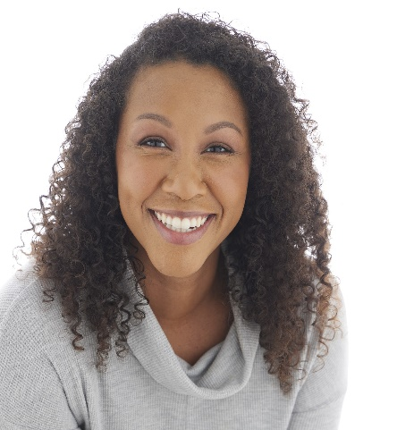
Sandra Kenly
Represented by Exposure Inc.
info@exposureinc.com
Height: 5’8 | Eye Color: Brown | Shirt: M
Weight: 158lbs | Hair Color: Brown | Pant: 8
Phone: 913-317-8801

FILM/TELEVISION
Counteract | Principle | Beyond Pictures & Novels Productions
Taking Care. Saving Lives. | Principle | Opus Productions
Amethyst | Supporting | Skyla Hamilton (dir)
Beautiful Dead | Supporting | Beautiful Dead Productions

COMMERICAL/SOCIAL MEDIA/INDUSTRIAL
ADT Security Services | Principle | VMLYR
Planet Fitness | Principle | Barkley
Red Lobster | Principle | Barkley

TRAINING/EDUCATION
Acting & Scene Study I & II | Jeanne Averill | Wright/Laird Casting
On Camera Class | Dan Compo | Commercial Actors Studio
Intro to Voice Over Class | Eliska Hahn | Voices for All
Acting with a Camera | David Deblinger | HB Studios
Acting with a Camera ll | Magaly Colimon | HB Studios
Business of Acting in the Ozarks | Shelley Waggener | Bear Casting Studio

SPECIAL SKILLS
Athletic: Roller Blading, Basketball, Volleyball, Swimming, Hiking, Running, Weightlifting, Yoga
Musician: Clarinet, Saxophone
Dance: Modern, African
Entrepreneur: Public Speaking, coaching, facilitating, educating

