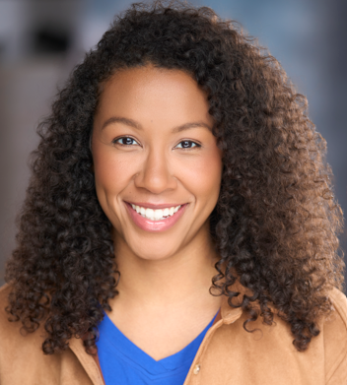
Sandra Kenly
Agent: Exposure - info@exposureinc.com
Height: 5’8 | Eye Color: Brown | Shirt: M
Weight: 155lbs | Hair Color: Brown | Pant: 7  Shoe: 10
Phone: 913-221-5511

FILM/TELEVISION
Trivia Night Mysteries | Supporting | Nicely Productions
Wicked Deeds | Principle | Tilted Light Productions
Capsule | Supporting | Wild Horse Productions
Counteract | Principle | Beyond Pictures & Novels Productions
Taking Care. Saving Lives. | Principle | Opus Productions
Amethyst | Supporting | Skyla Hamilton (dir)
Beautiful Dead | Supporting | Beautiful Dead Productions
Voice Over: Anomaly | Principle | Synder Films

COMMERICAL/SOCIAL MEDIA/INDUSTRIAL
ADT Home Security | QT | Jet Linx
Planet Fitness | Hallmark | Mount Vernon Museum
Red Lobster | Salvation Army | Capital Federal Bank
Jefferson City Bank | Ascend Learning | SkillPath
DM Law | Spire Natural Gas | Wendy’s
Indiana Wesleyan University | Jensen Tire | El Monterey
Backyard Discovery | Kingdom Networks

TRAINING/EDUCATION
Acting & Scene Study I & II | Jeanne Averill | Wright/Laird Casting
On Camera Class | Dan Compo | Commercial Actors Studio
Intro to Voice Over Class | Eliska Hahn | Voices for All
Acting with a Camera | David Deblinger | HB Studios
Acting with a Camera ll | Magaly Colimon | HB Studios

SPECIAL SKILLS
Athletic: Sprint Triathlon, Roller Blading, Basketball, Volleyball, Swimming, Hiking, Running, Weightlifting, Yoga, Kickboxing Dance: Modern, African Entrepreneur: Public Speaking, Coaching, Facilitating, Teleprompter Reader: Proficient; Pistol Handling and Kickboxing

