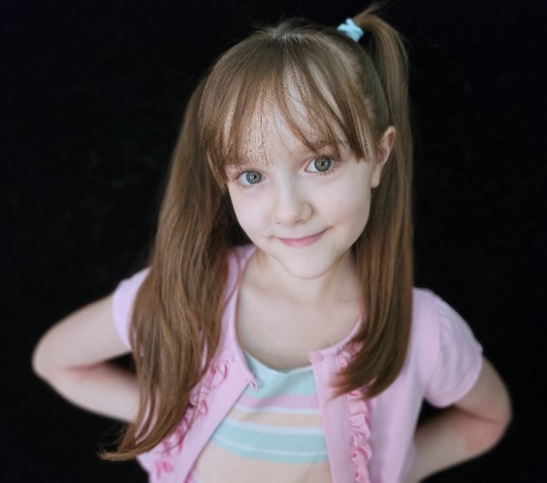
Stelleyn Mayer
Represented by Exposure Model & Talent
info@exposureinc.com

Age/Grade: 10 years old/5th
Eye/Hair color: Medium blue/Light chestnut brown
Height/Weight: 51 in./50 lbs.
Build: Short/Slim-Regular/Athletic
Size(s): Clothing- Child 7/8, Shoes: 13

Experience: Main talent (“daughter/little sister”) in Worlds of Fun & Oceans of Fun commercials, Summer 2023.
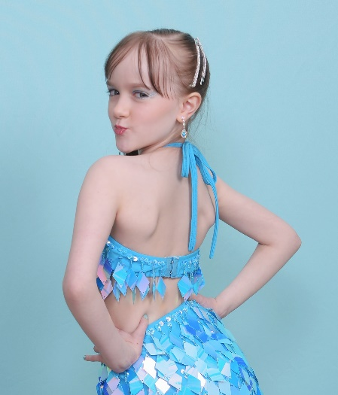
Served as a paid audience member for the filming of the reality show Second Chance Stage in 2024.
Musical Theater in dance class. Performed in recitals since age 5. Was invited to audition & join her studio’s competition team where she has won numerous medals & other awards.

Extras: An avid watcher of many genres of movies & TV.

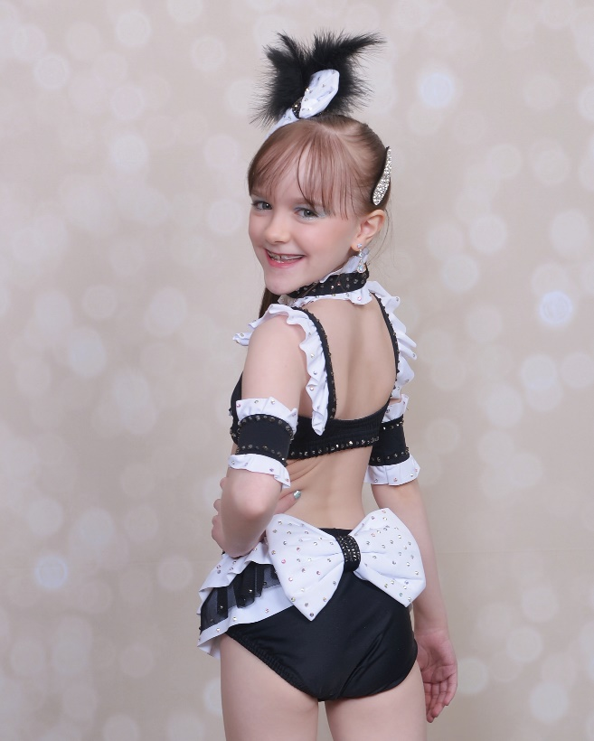
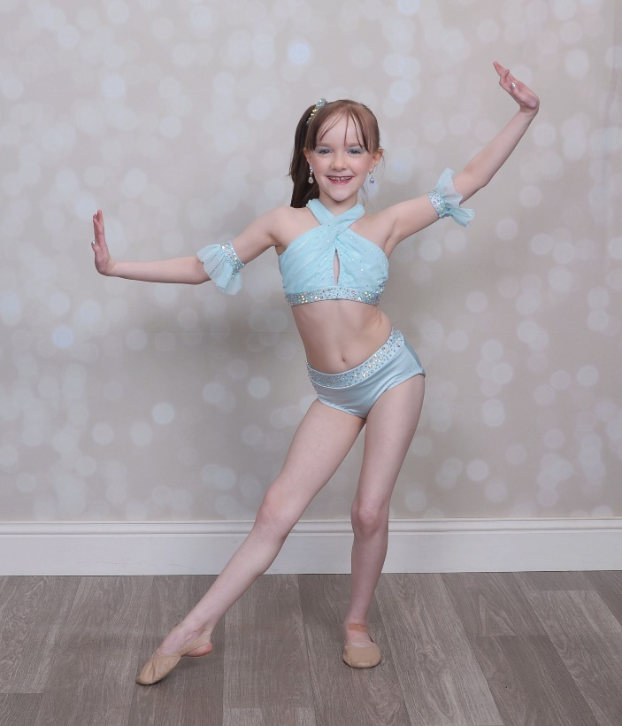
Skills: Dancer since age 5 in tap, jazz, ballet, & lyrical; has also taken classes in hip hop, yoga, technique, & acro (1 & 2-handed cartwheels & round-offs, extensions, splits, backbends, etc.). Sensitive, emotive, precocious, creative, outgoing, imaginative, witty, empathetic, & disciplined.

